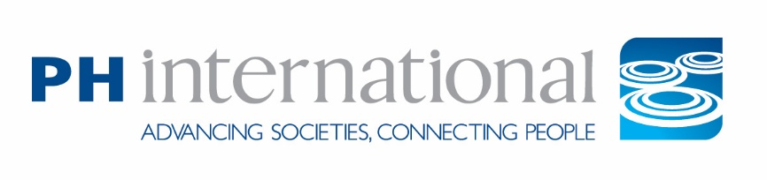
Program Manager – International Sports Diplomacy
PH International (Project Harmony, Inc.) is an international non-profit with 40 years of experience focusing on community engagement and cross-cultural learning. The U.S. headquarters is located in Waitsfield, VT, with projects implemented globally.

Location: Waitsfield, Vermont (Hybrid)
Start Date: As soon as possible, but no later than September 1, 2026
Salary: $55,000–$58,000, commensurate with experience
Application Deadline: Friday, July 31, 2026

PH International (Project Harmony, Inc.) is seeking a full-time Program Manager to support the planning and implementation of international sports-based and other exchange programs funded by the U.S. Department of State. Based in our Waitsfield, Vermont office on a hybrid work schedule, the Program Manager will coordinate all aspects of assigned exchange programs, including logistics, partner communication, participant support, financial management, and post-program evaluation.

The Program Manager will be responsible for leading up to three domestic and three international 10-day sports diplomacy exchanges annually, supporting adult coaches, administrators, and youth influencers to implement community impact projects and build global networks of sports leaders. The position requires strong organizational skills, cross-cultural communication, and, ideally, some background or knowledge of grant compliance or budgets.

This is an excellent entry-level opportunity for someone with a passion for international education, sports for social change, and public diplomacy to join a small, mission-driven nonprofit and make a global impact.

How to Apply
Please email your resume, cover letter, and answers to the questions below to: development@ph-int.org
The subject line should read: “Program Manager – [Your Name]”
No phone calls, please.
Application Questions:
Please respond to the following questions in your application:
- Please describe your experience managing or supporting domestic and international programs, particularly with wide-ranging global audiences.
- Why are you interested in working for a small Vermont-based nonprofit like PH International?
- This role includes frequent travel. Are you comfortable with both international and domestic trips several times a year?
- What experience do you have managing logistics, grants, or partner relationships in a cross-cultural context?

Benefits
PH International offers a competitive benefits package that includes:
- Medical insurance
- Four weeks of CTO (Combined Time Off) each calendar year
- Nine holidays and an additional winter break (December 24–December 31)
- Increased CTO with tenure

